Video 2 Day 10

Default volume of a root

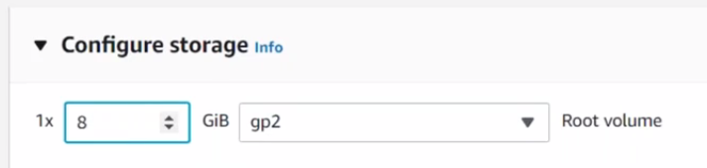



Installs the new package.

Yum is the utlity s/w in linux. Its having configuration in a location called



By default these 2 installs

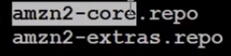 Repository

When you enter into this we can see the mirror list this is where the link is given. It explains from which internet link it has to download the packages.

By default amazon Is maintaining all these repositories. The yum command is just connecting the link and downloading the packages.

Core repository:- this all having the major os related pakages.

Extra repo.= this is the place where amazon is maintaining the 3rd party open source not directly related to the os but may be some open source 3rd party . all those will be kept into this particular.

Apache package is installed in 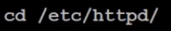

To check and start the service 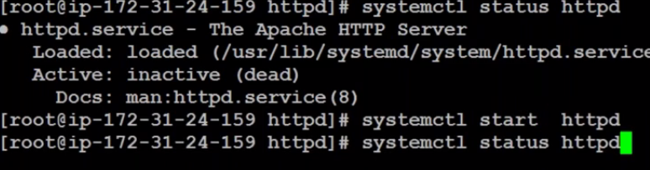

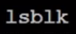 it shows the how much the server is taking the volume and how many volumes are attached.

Asking aws to store your data in new folder.

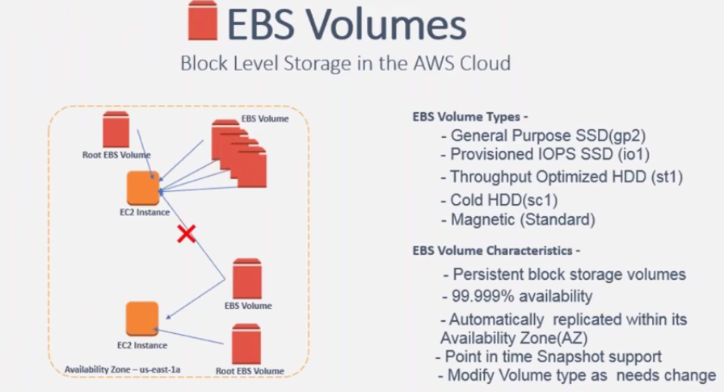

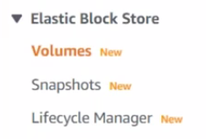 Create a volume Select the size and location

Both volume and server both should be in same availability zones

Check in your ec2 instance and

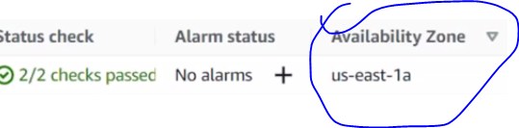

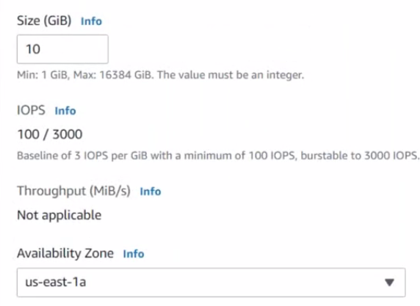

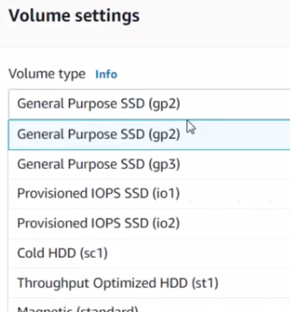 these different types are io1 can be editable to select the volume.

99% use gb2 ssd

Create volume

Now vol is created. To link to your ec2, select the volume= actions= attach

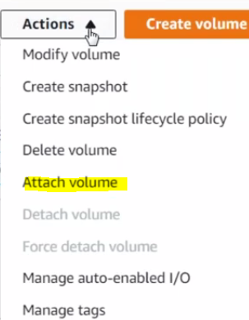Create name and select the server. ==

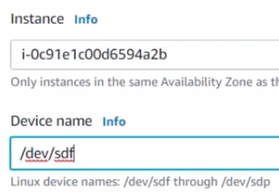Attatch the volum

* To check how many volumes are connected.
* Go to dashboard== select the server== storage= 2 volumes are attached
* 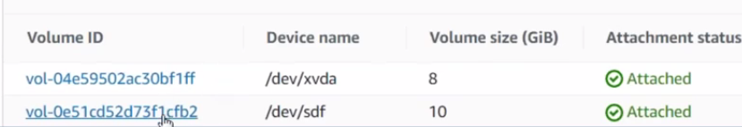
* Any volumes stores in /DEV
* 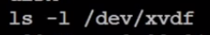

Now put the website data into this volume???

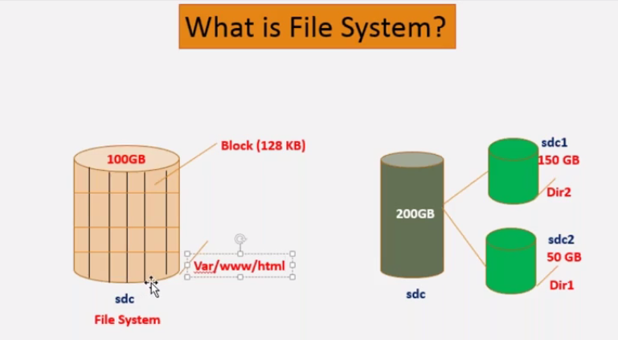

You cannot store the data directly

Storing the data in xvdf drive.

Mkfs – creates a files system.

File system can be created in multiple types.

Which type are you using to format the drive. This differ what COULD BE THE BLOCK SIZE, how much big size.

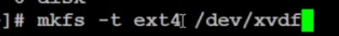

It clearly says this

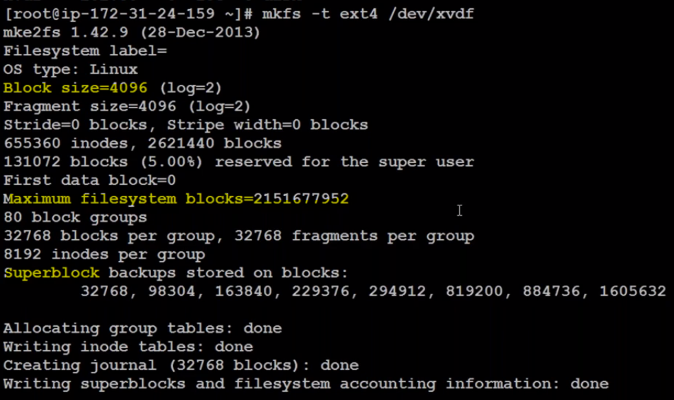

Step 2=>



/var/www/html is a directory is mounted on /dev/xvdf volume. Now on wards any data that we store under this will actually be stores into volume.

Mount:- attaching the directory to volume.

Now create a index.html file

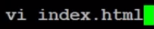

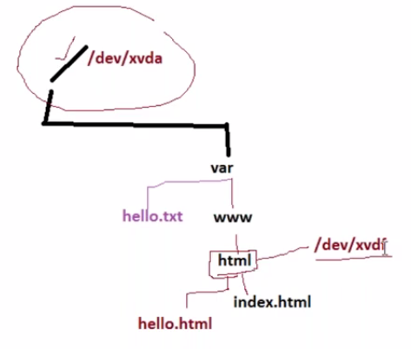

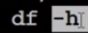 disk file sysyem, human redeable

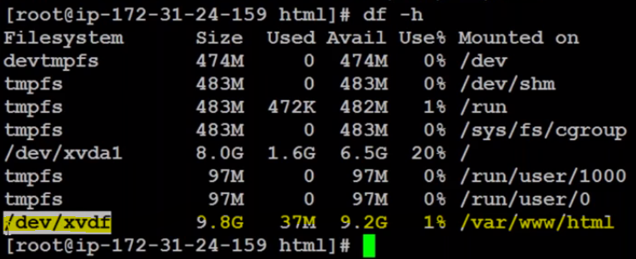

Whenever if you use this volume you can mount If not unmount.

Mount & unmount

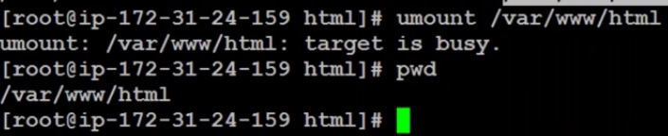

When you are inside this directory you cant close it

Run df-h:- unmounts will not be appeared in this command.

Df-h shows only mounted file system

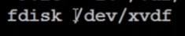 is used for partition the drive

Video 6 LINUX Introduction

Shell??

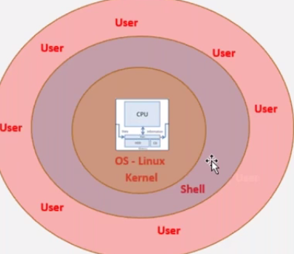

Create EC2 instance

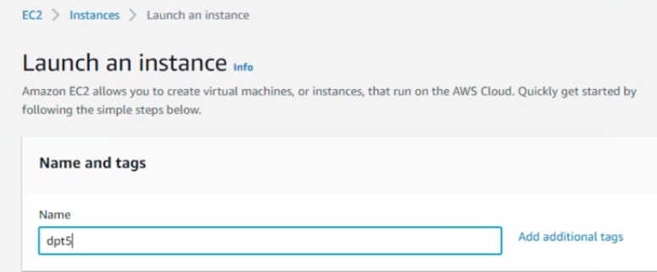

Select AMI, T2 tier, select Key

Scroll down and launch instance



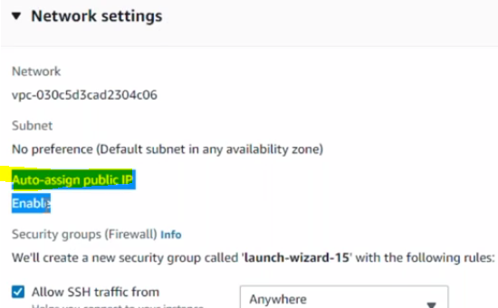

If this is enabled you will get a default IP address from server.

If you don’t like it you can use Elastic Public IP

Launching instance

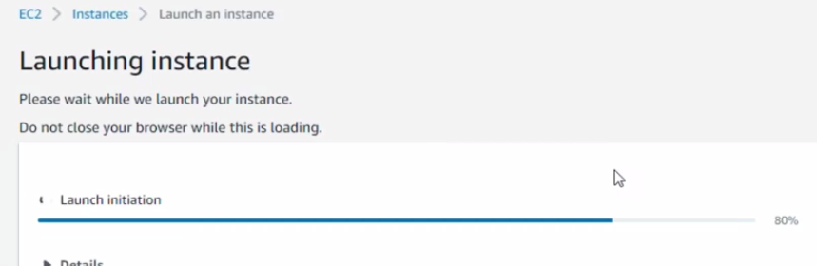

Instance is launched

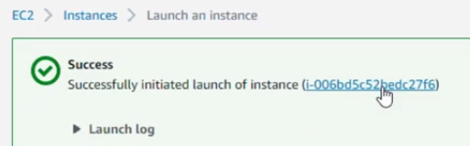

Now you can see the public IP

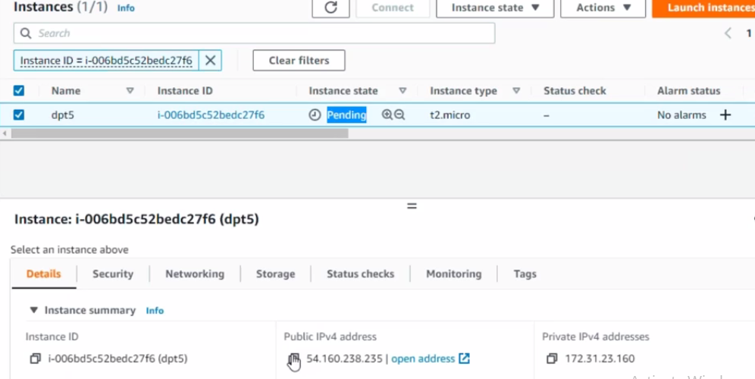

Logging into the server

Open putty

Enter details IP address and key (SSH tab – Authentication tab==browse Key)

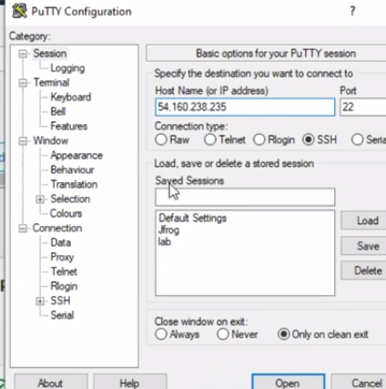

Once you login into putty. What you see is a shell prompt

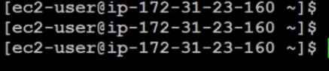

EC@-User is an ardinary user that means this user doesn’t have a permission to run any command that you like it.

To login into ROOT User

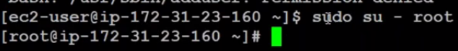

Swithed from ec2 to root user

If you wants to check the user which you logged into the linux user use

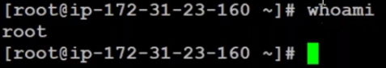

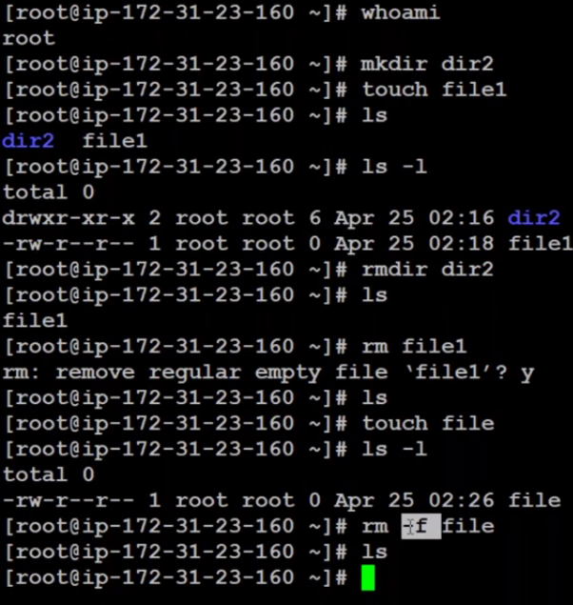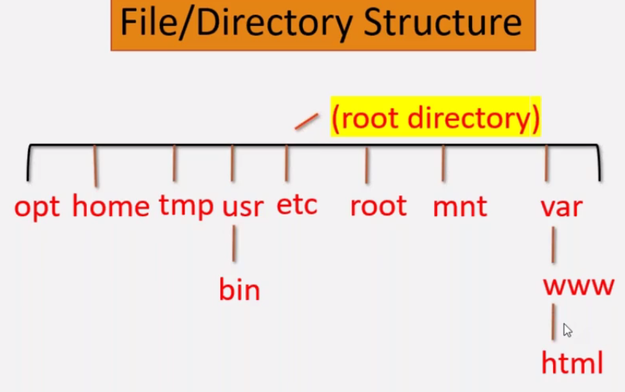

Video 7

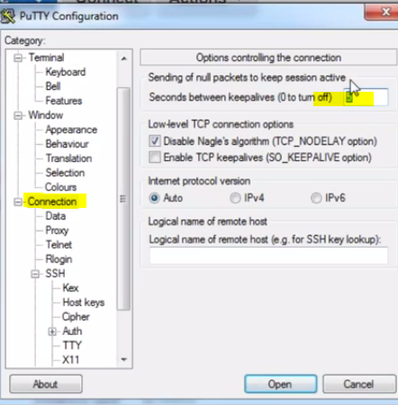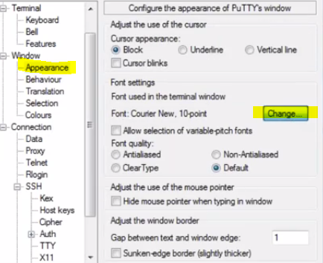

Give a non Zero value so that it doesn’t terminates automatically

To change the appearance increase the size go for connections.

To know the public key location

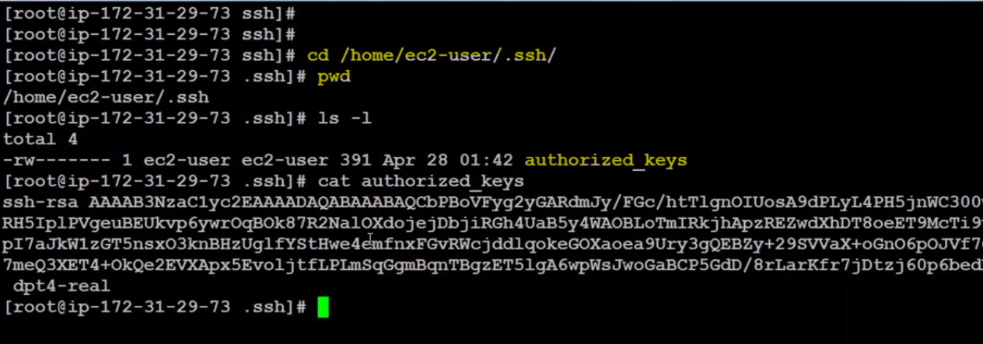

. \.

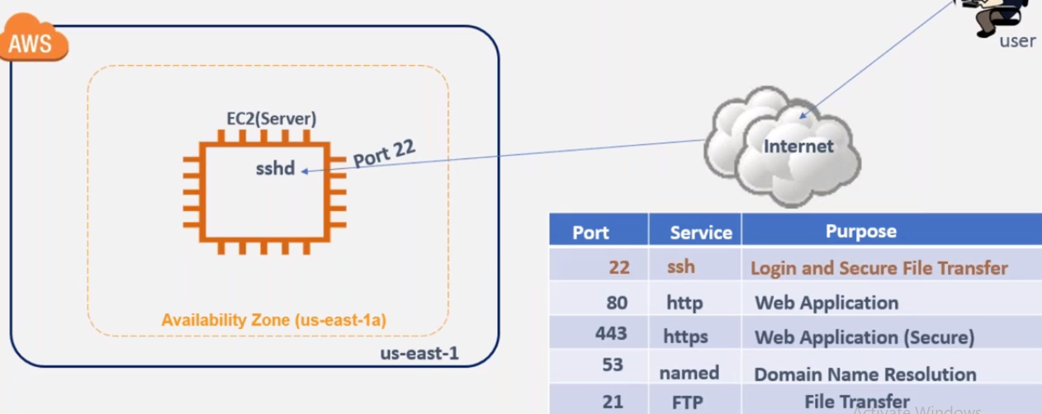

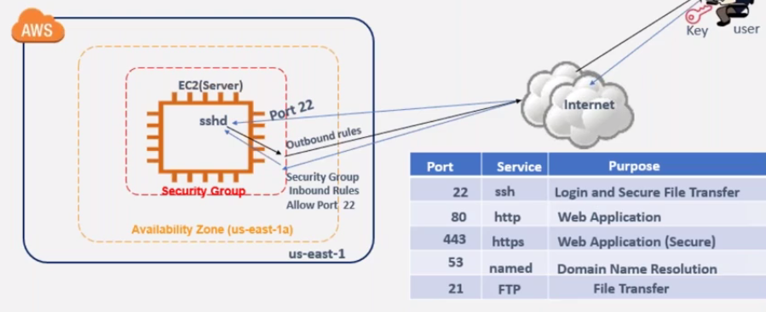

Under network settings

Under security group firewall

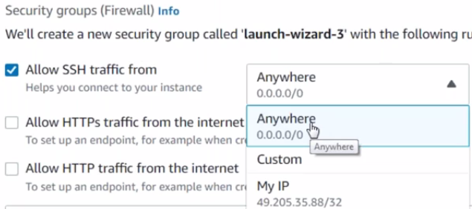

Existig server

Security == Click on this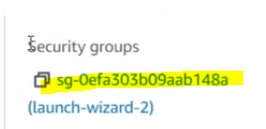

Navigating into this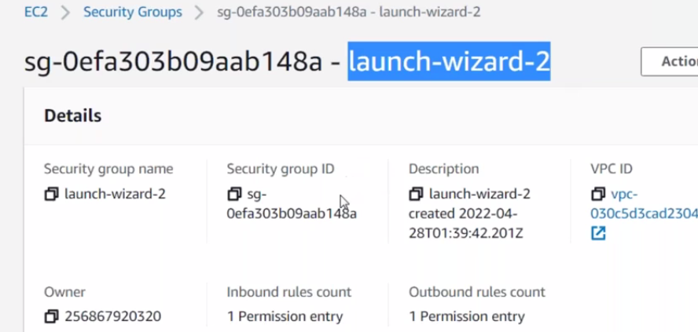

Scroll down inbond rules

Edit inbond rules

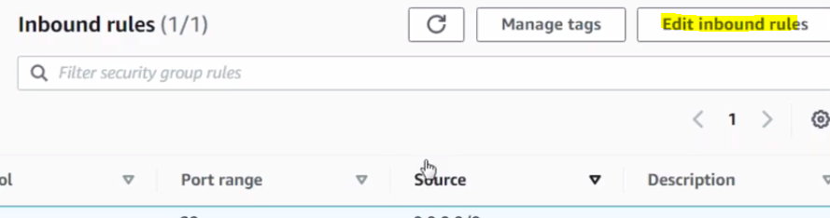

Change custom to my IP

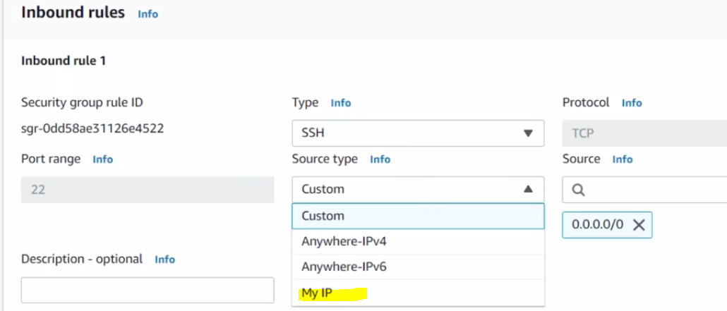

Save the rule

You can add multiple inbond rules.

Under network setting you can see the security drops

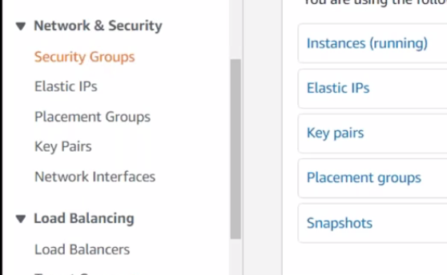

You can create new security group from here as well

V9

How to host a website in the linux machine.

How to install a package in linux machine



Yum is called a package manager for linux machine.

It knows where the package is from install in the location.



List is the command where verify the package is installed or not.

 Default home directory of HTTP

ETC is the location where all configuration data will be deployed on the folder.

When you install httpd it always install a service



To know the status/ to verify the service

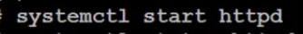 start the service

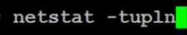 to verify the port number

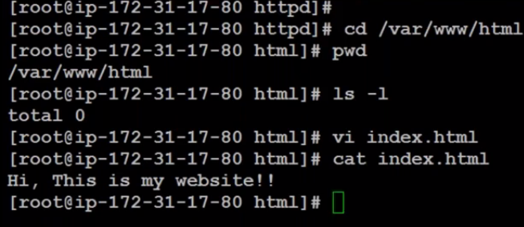

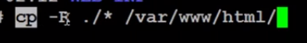

Cp copy the date

-R Recursive ( coping the multiple data)

. psw

Star is all,

/var/www/html is the location you need to paste.

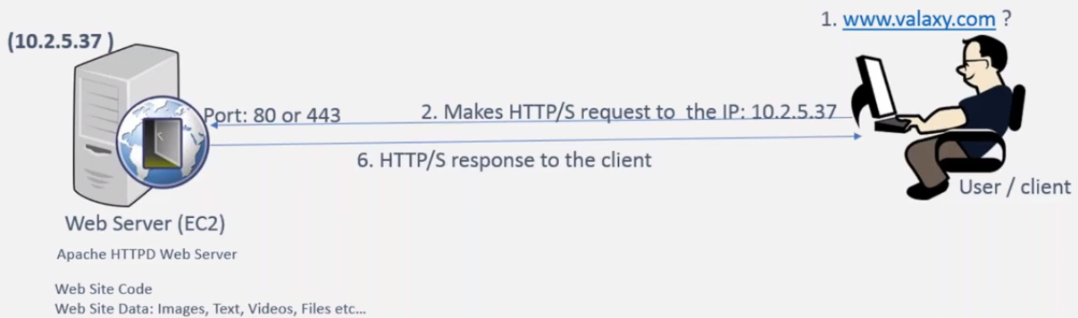

DNS Service is helps to convert name to an Ip address.

Video 12 7/20/2023

Cloud Watch

Creating the volume. Its imp that while creating the volume your EC2 server should match with the EC2 region

GO to volume section: create volume == select the vol type and configuration , encrypt the volume with kms key-== create volume.

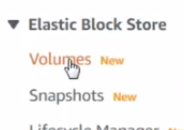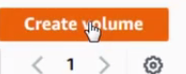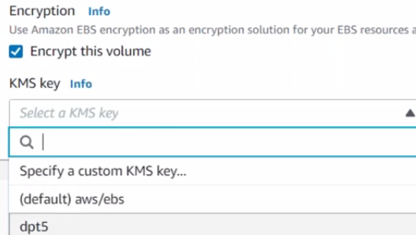

Now attach the volume

Go to actions= attach the volume == select the server from drop down and ATTACTH .

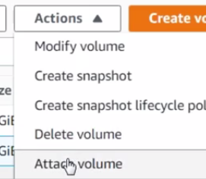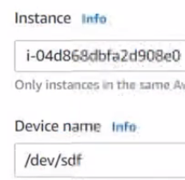

To verity it login into putty and run LSBLK Command

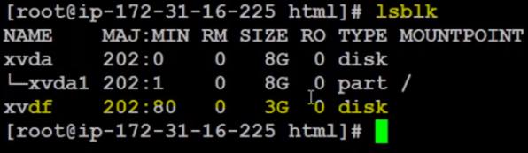

Now create a file system and store the data.

Write mkfs –t ext4 /dev/xvdf file system is created



To mount into mnt folder== 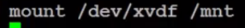

mount /dev/xvdf /mnt

run ls –l /mnt 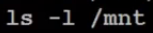

run df –h : it will show the mnt which is close to 3GB.

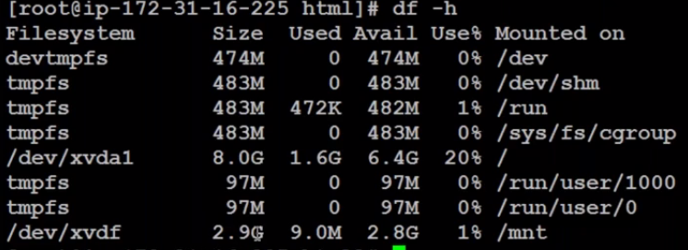

How do we increase the volume capacity and file system capacity ??

Increasing the volume is infrastructure related & aws will do it for us.

Go to aws console – storage – select the which volume we need to increase

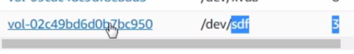

Click the vol id – select the volume –actions –modify volume- here we can give additional size. == final modify. We cannot decrease it it states error

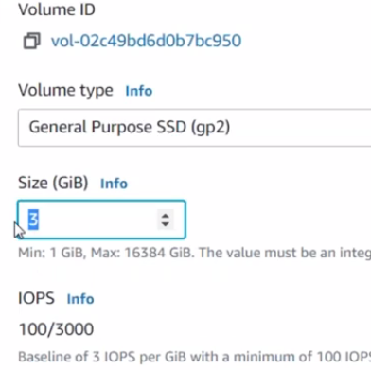

Run lsblk now you can see the increase size

Run df-h . mnt will be reference to the old 3gb.

To match this run resizefs / dev/xvdf : it resizes the file system as well into the newly added capacity,

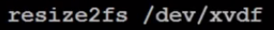

Now check with df-h . it will reflect with the new size.

Free –m which will tell the memory utilization –m is the mb format

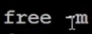

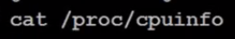 It will give you info about the processor.

* to see the utilization of the cpu, memory ,processor.

Which command is consuming the processor, if the cpu is going near to 100%.

You need to take the instance type like scaling the like t2.micro to t2.medium. need to take trouble shooting and take current actions.

Top command will give the real time data ie.. at this time which command is executing and taking more memory.

How you decide whether web processor is 1 processor or 2 processor/10,

That depends on the more users and accessing the web application.

Initially we go with the minimum then if users are increasing then we can increase the capacity . either cpu is touching 100% or minimum threshold.

Inorder to comeout from this give Q command.

AWS gives a monitoring tool that is called as cloudwatch .

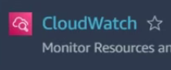 it will monitor the number of metrics of the cloud resources, It means that cloud watch is the service which is monitoring all of the resources that you are creating the AWS cloud. This wil monitor only AWS resources nothing else.

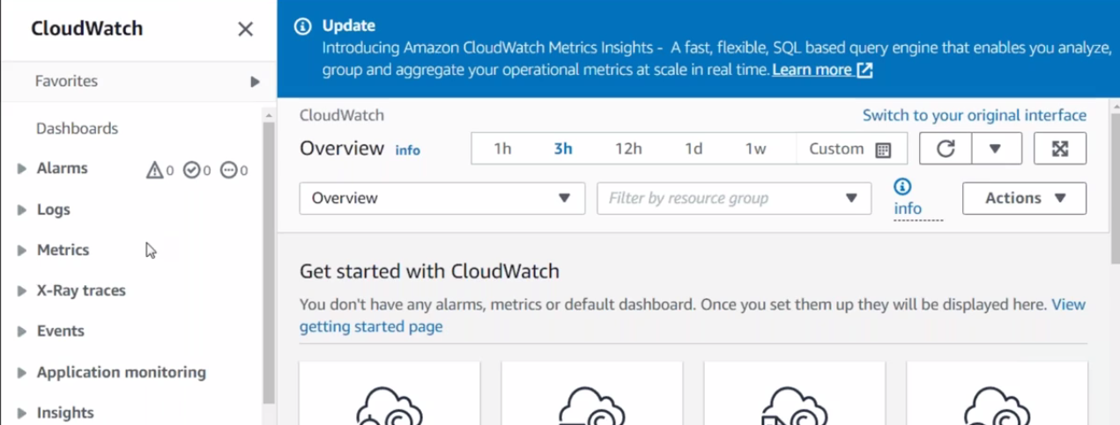

Metrics🡺this states that the particular component you are interested into do the monioting ex:- cpu, memory

click on metrix tab and all metrics

go with the cpu utilization then click EC2

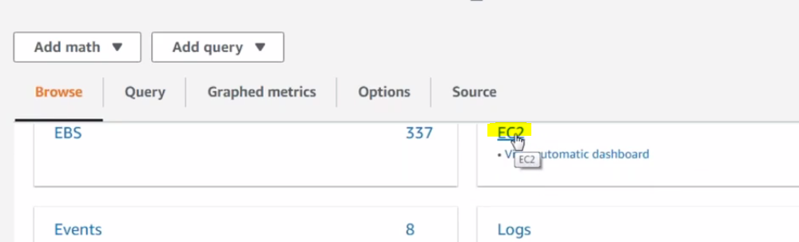

Per instance metric

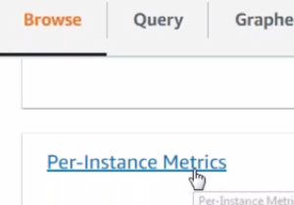 it means wants to see the specific if Ec2 server.

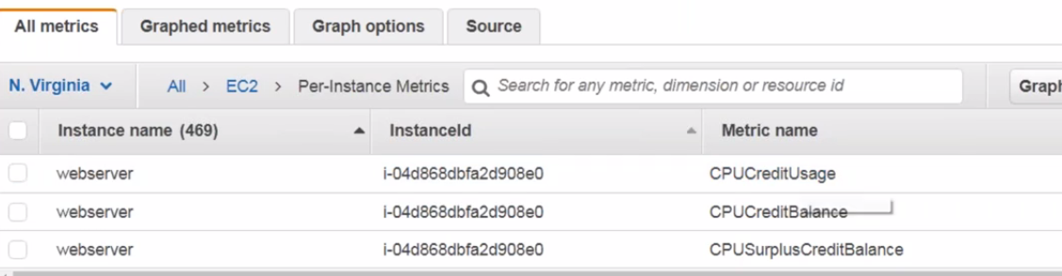

Search with the instance id and select that. It will show the graph.

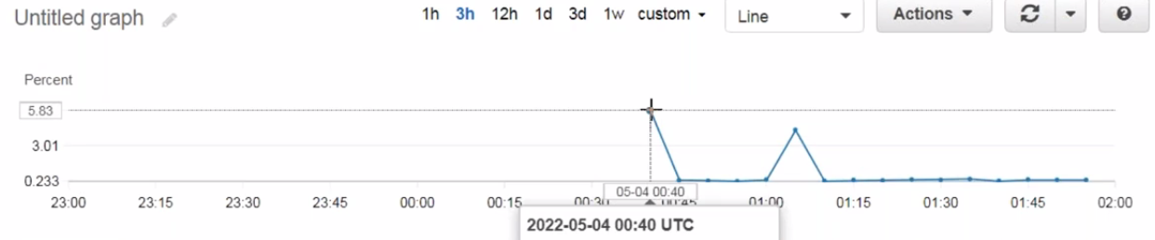

You can see the last utilization till last 15 months

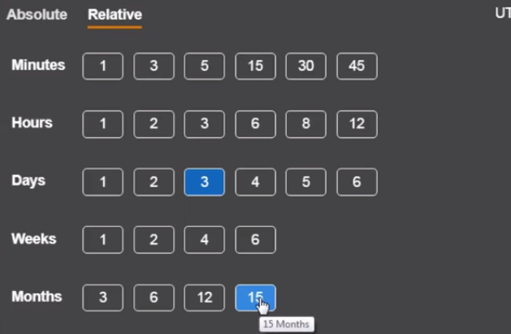

There will be another monitoring tab on the EC2 server.

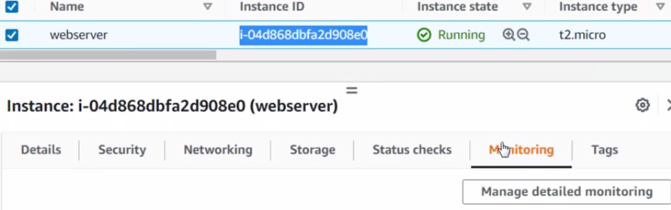

Instead of all the metrics its better to create a dashboard and create your fav.

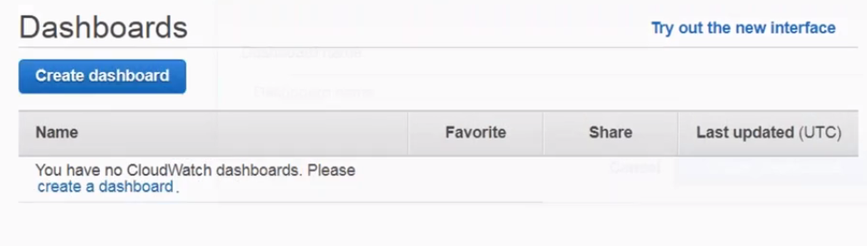

Give the name

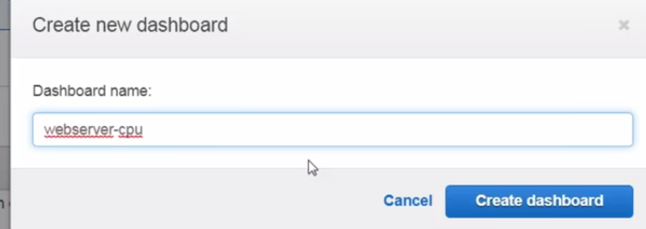

Its asks data which should appear in this models

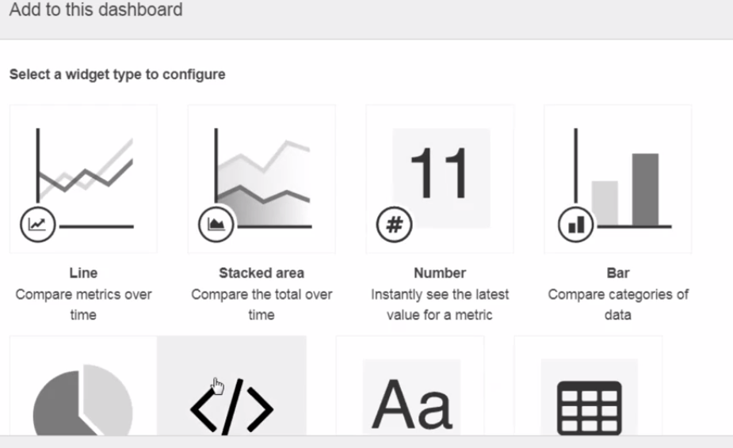

Now select the metrics EC2 – per instance metrics. Cpu utilization – create wedget. Save the dash board. Now you can see the dashboard

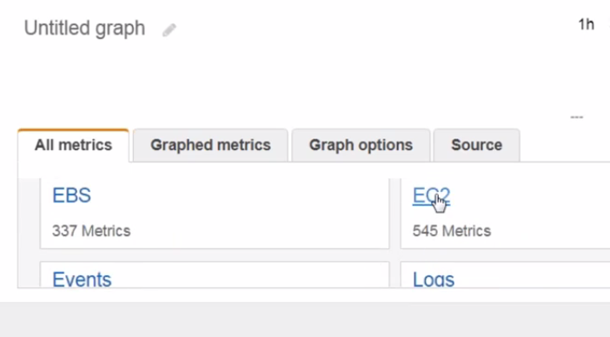

🡺how do we know that it gets 100% , we cannot watch each time.

Alarms🡺 cloud watch alarm to notify if its crosses threshold.

Insufficient: doesn’t have enough data to compare and take the decision.

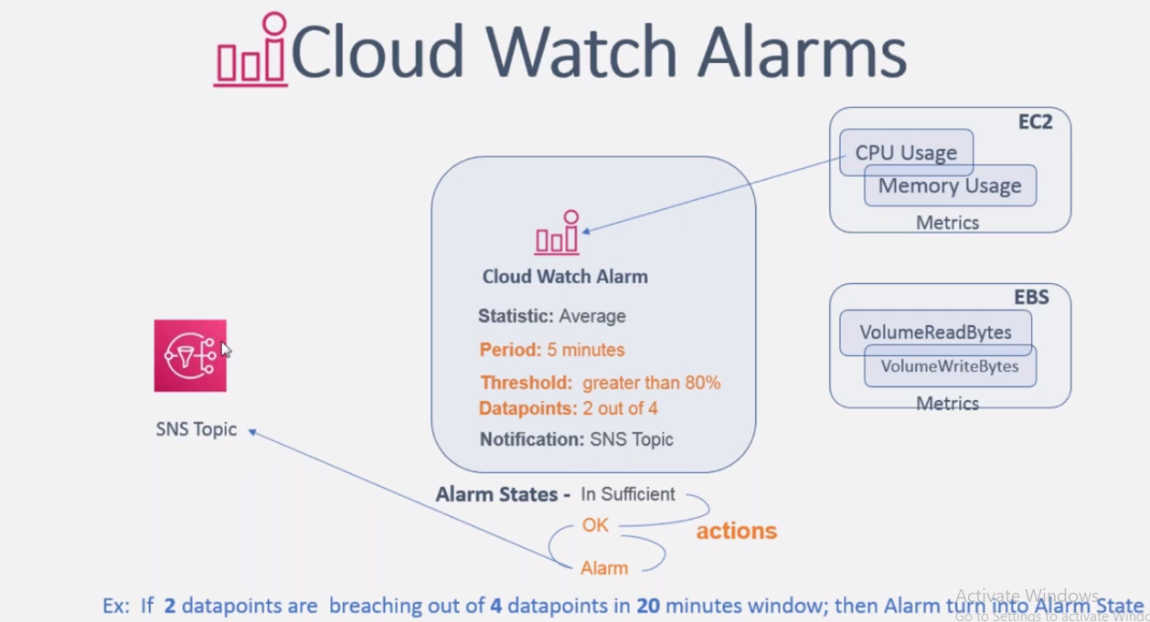

SNS system:= simple notification service

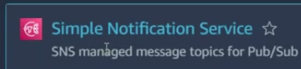

Here are 2 things which we need to notice

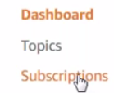

Topic :- category what type of alarm should go to whom.

Create topic. Just to divide which type of alert to go to whom.

We will use standard 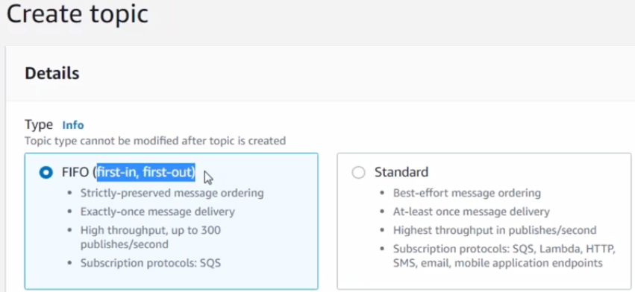

Write name & display name for alarm create topic

Now go to dashboard and click on topic there you can see the topic.

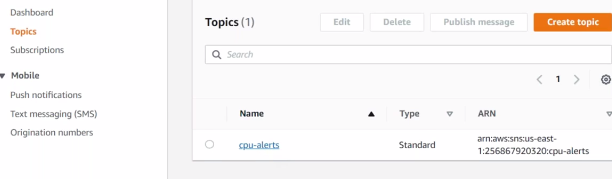

Add subscribers 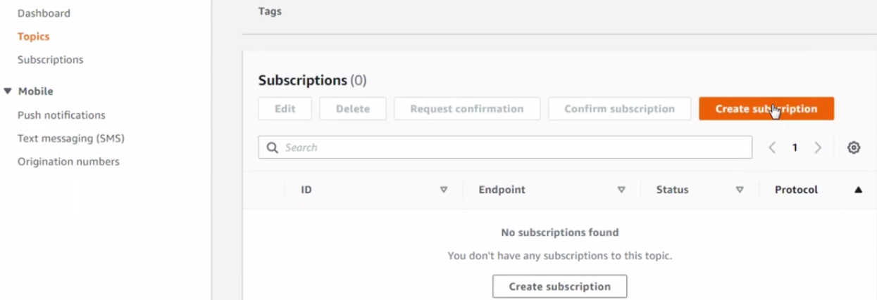

List of protocols you wants to configure.

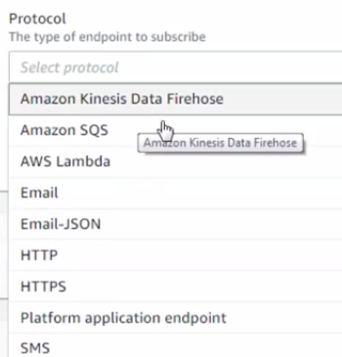 choose email

Select the email id

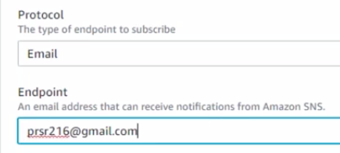

Create subscriber.

The moment you added it will be in pending state.

A email sent to the subscriber for confirmation. Once you confirms

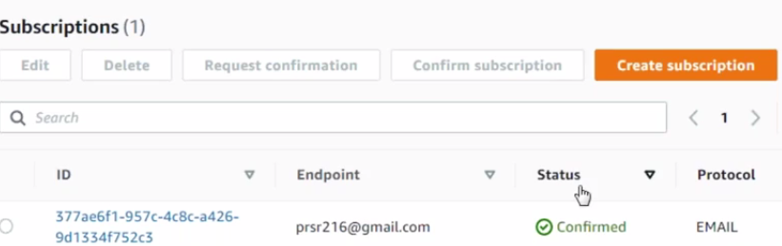

Now create alarm and configure

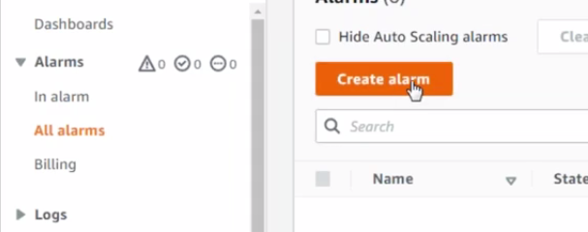

Select the metric

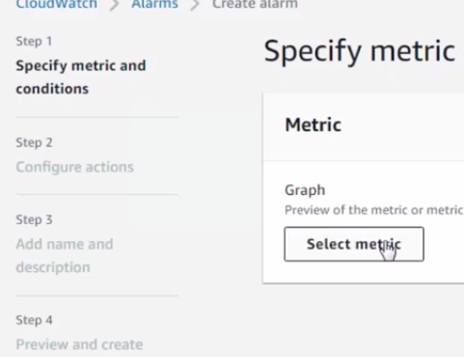

Choose metric from the list ec2 – cpu utilization.- select metric

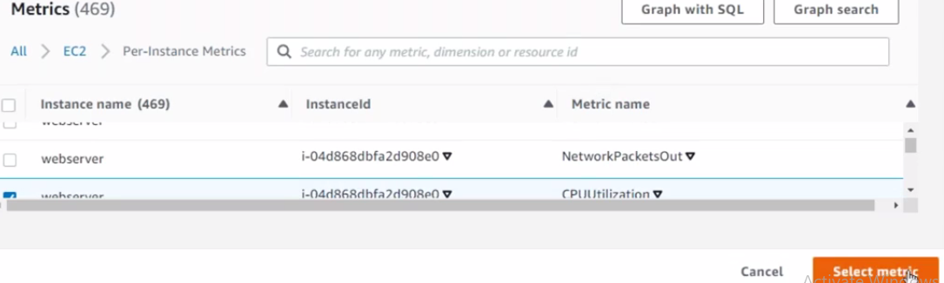

Select the average duration

Select the condition

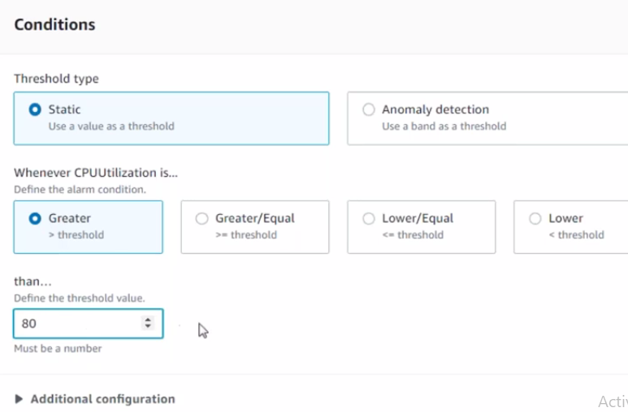

Next

Notification

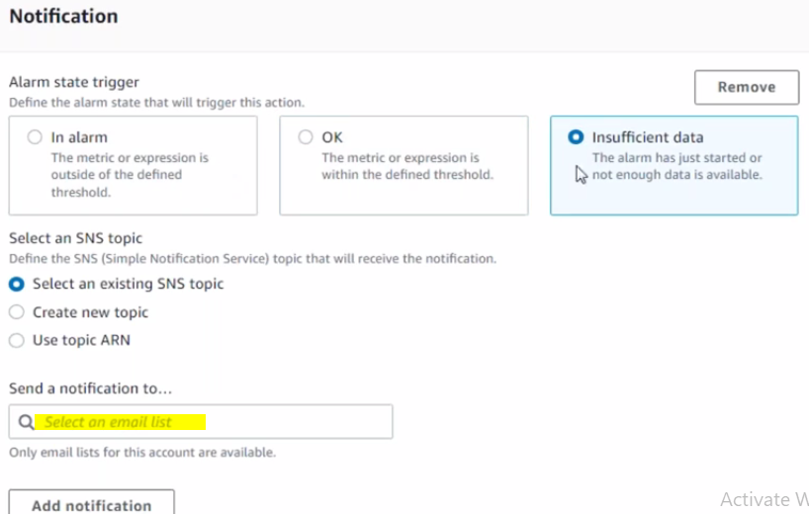

Next == write alarm name and description

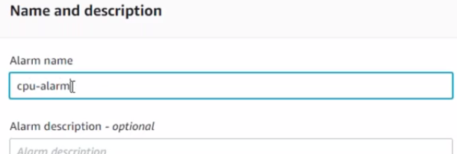

Create alarm

Initially its will be in insufficient stage after some time, it wil change to oK

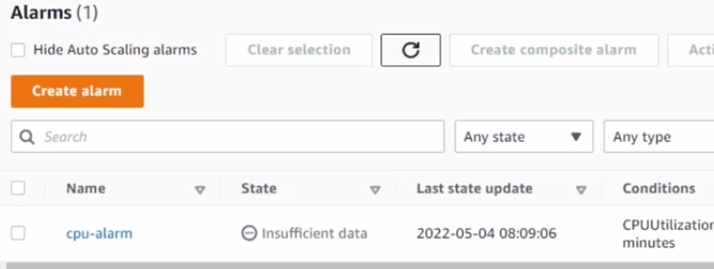

Go to google and search EPTL packages which are proving 3rd party to linix added packages.

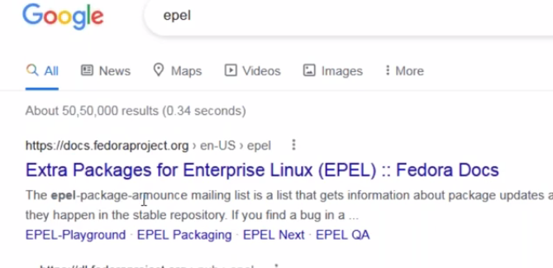

To check the repository 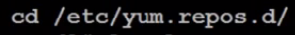

These are available as part of amazon- extra repo

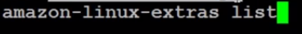 this is used to see the list of packages supported by the extras repository.

 this command is used to install

Now epl installed

Now use Yum command to install stress package

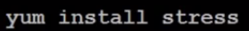

Now alarm changed to alaram stage

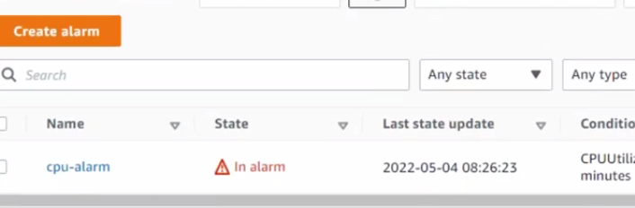

Click cpu-alarm.

You can see the usage

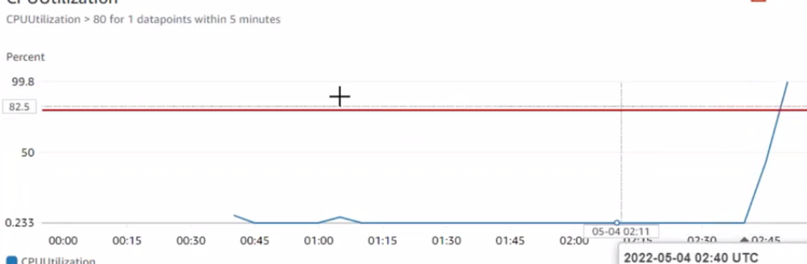

Come down and click history

This will tell you the status

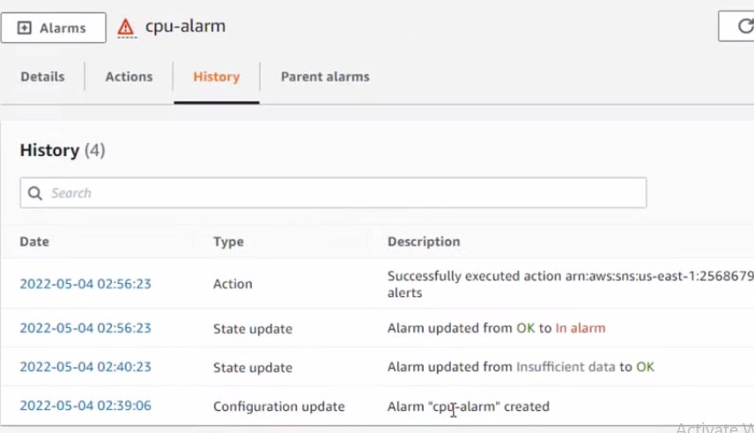

Video 1 3

S3

S3 is the simple storage service offered by the AWS its going to solve the problem

S3 is the cloud based storage solution its offering the pay as you go services.

S3 bucket will create with zero size. Bucket will adjust sizes based on the data size

Its stores in a file format

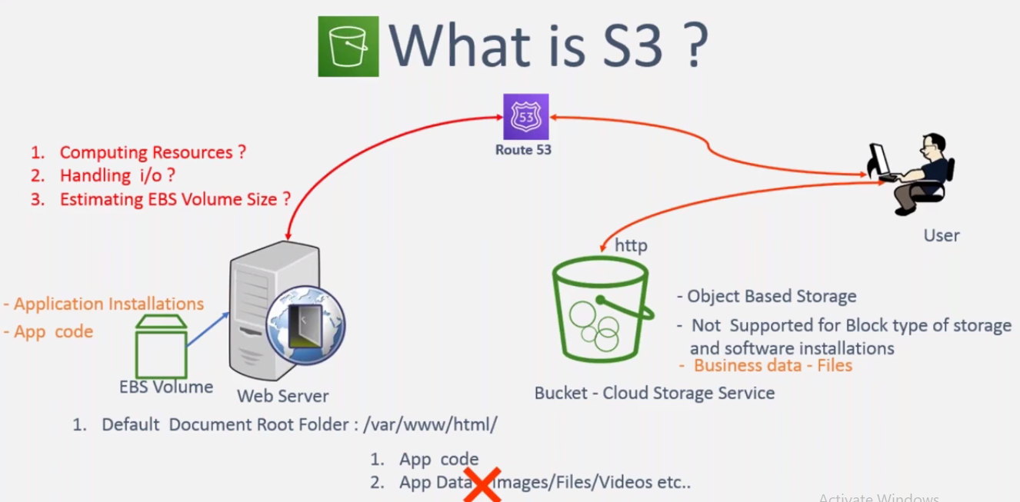

Create a bucket

Search s3 in cosole create bucket 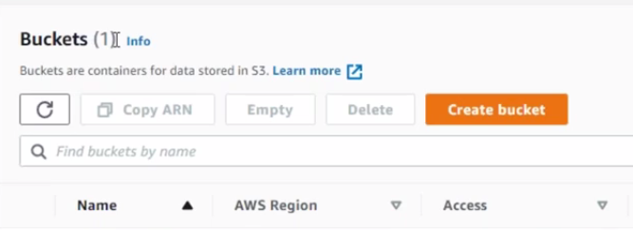

* give the name
* select the region
* object ownership -- ACLs enambled
* create bucket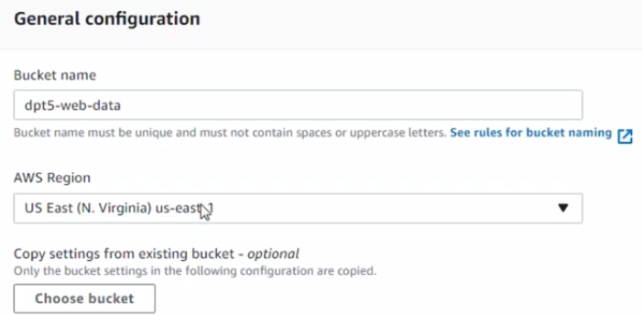

enabling the bucket version go to properties

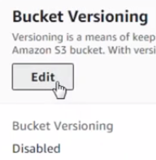 make it enable . edit , enable save

Select the version which you don’t like it and delete it.

Frequently accessible data

In frequently accessible storage class

Life cycle rule

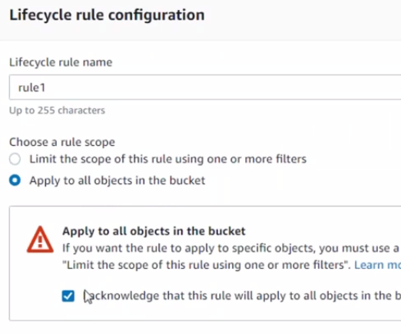

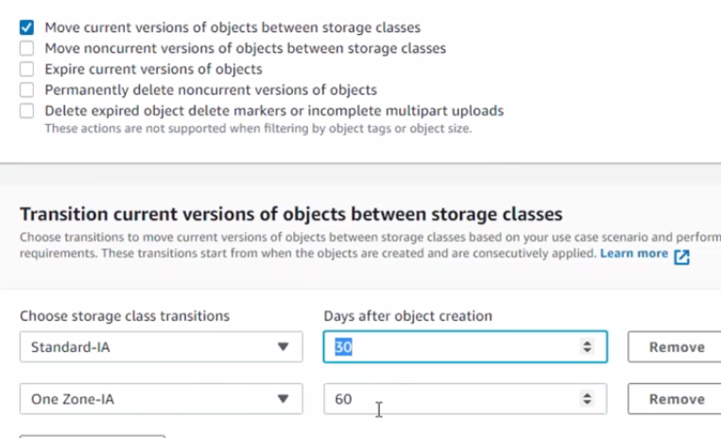

Video 14 IAM 24/7

Identity Access Management

IAM policies: JSon format , key : value

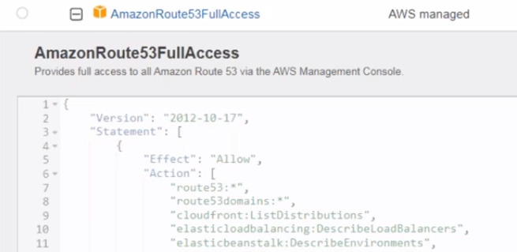

Aws managed policy or own constructed policy

* create a policy

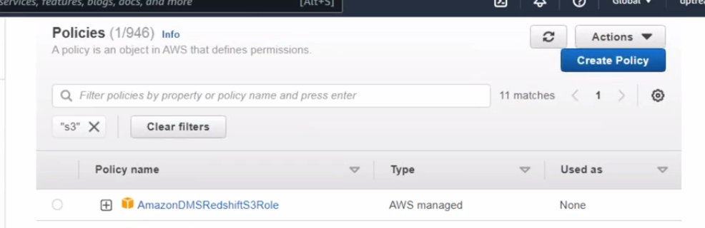

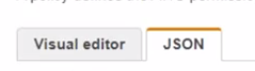 we can construct in these 2 ways

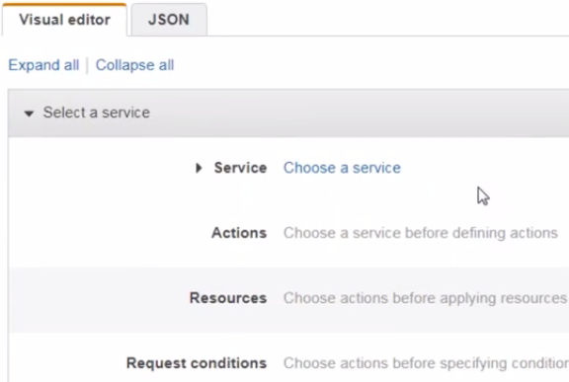

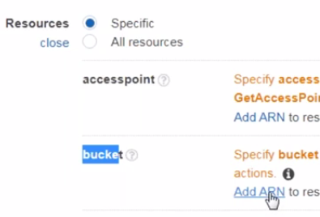 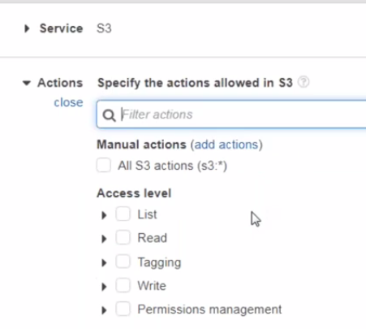  
Amazon Resource Name

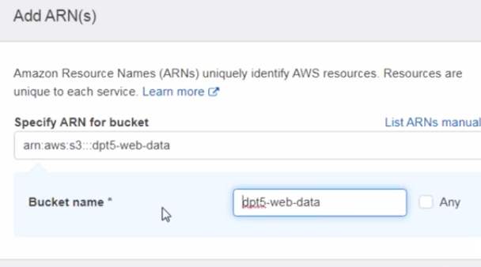

Write name and description of the bucket, create a policy

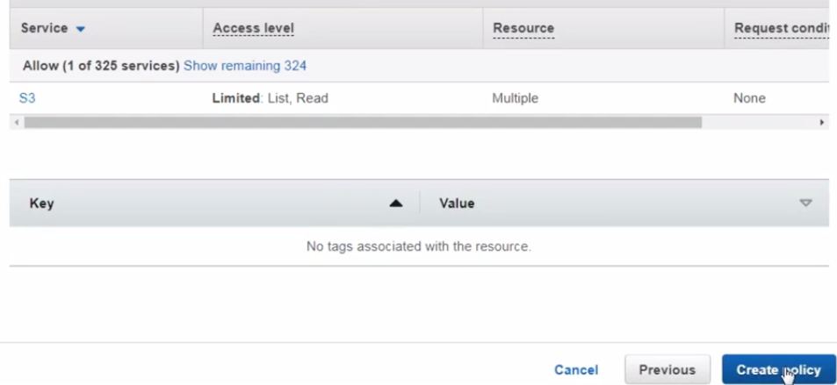

Now add this policy to the user by going to the user section

* Add permissions – attach existing policy-- search – add permission

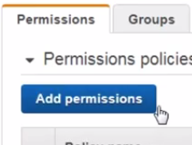 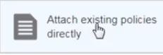 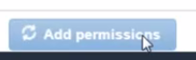

* Adding individually or create a grp and add all into that users and give permissions into that.
* Creating the credentials
* 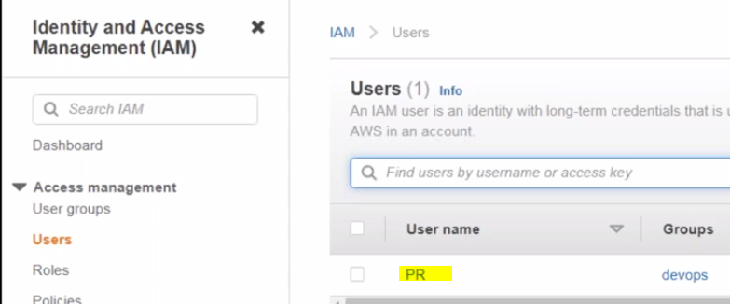

Go to user security credentials

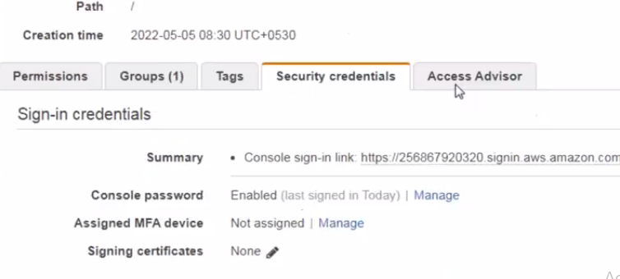

From here you can generate the key

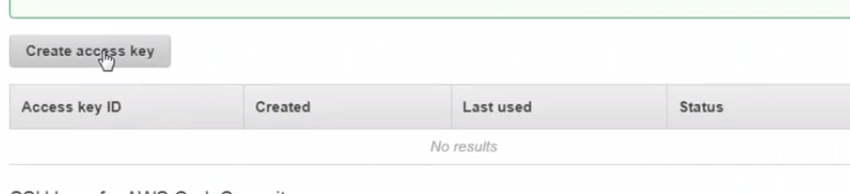

Download the key

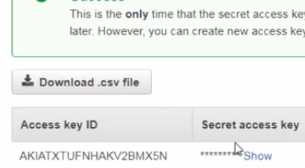

Install the AWS CLI from google and it’s a command line interface similar to linux CLi to interact with the AWS account

Select the O/S

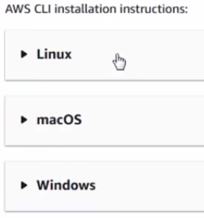

AWS CLI Command Line Interface

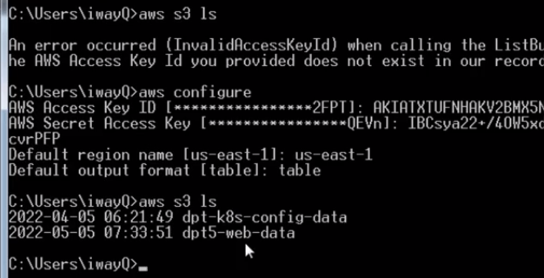

Go to google and AWS CLI interface and check the commands which is useful

Iam ROLE

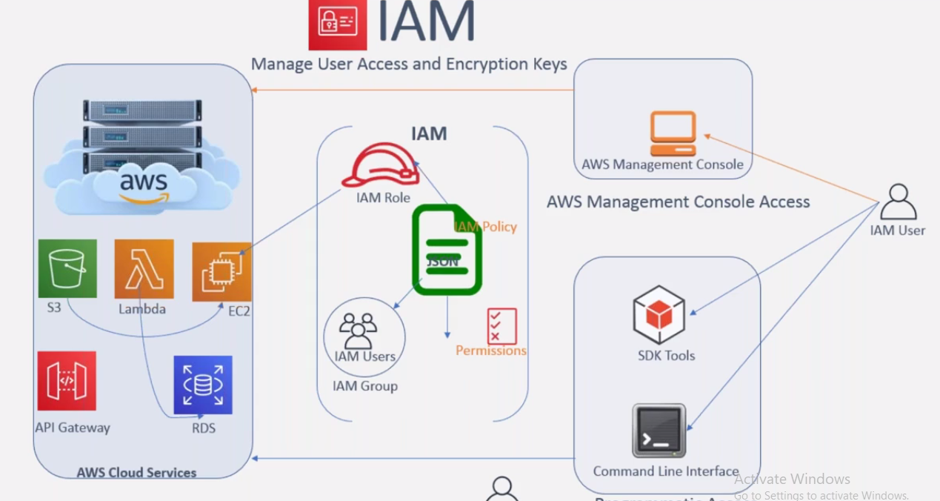

SDK Tool:- software development kit

The developers also be using the access key and secret access key in their code so that the program has to connect to the AWS

Terraform is an SDK Tool

We need permission to talk to one server with other server

If one service wants to connect with other service the role has come into the picture. Create a IAM role and attach the policy to the role and permission that u r trying to give . the same policy will give it to the user and role.

First give the role and attach it to the service

Iam users given to the specific individual who can login and run commands and do something

IAM Role is something which we given to the service level not to the specific user level only the resources make use of the IAM role not the specific people.

By default AWS CLi is installed if not install with the command

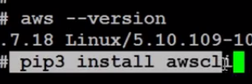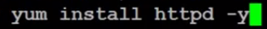

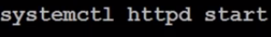 start httpd

Log file 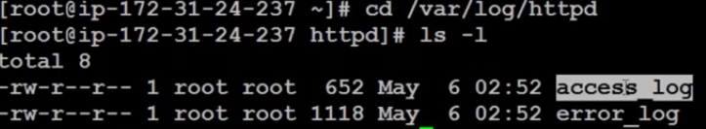

This log file should upload into S3 bucket

Now create IAM role with s3 permission and that role given to the EC2 server

Go to IAM and create a role

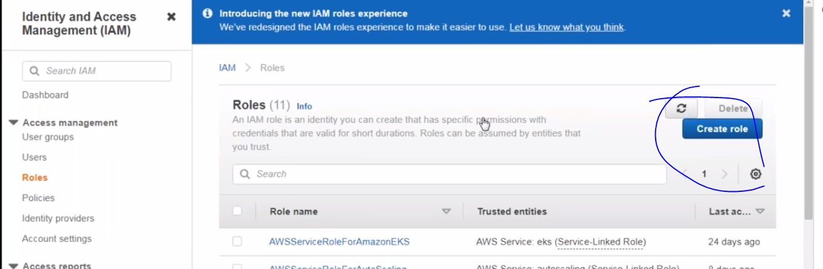

Now its asks the trusted entity it means that who wants to use this role

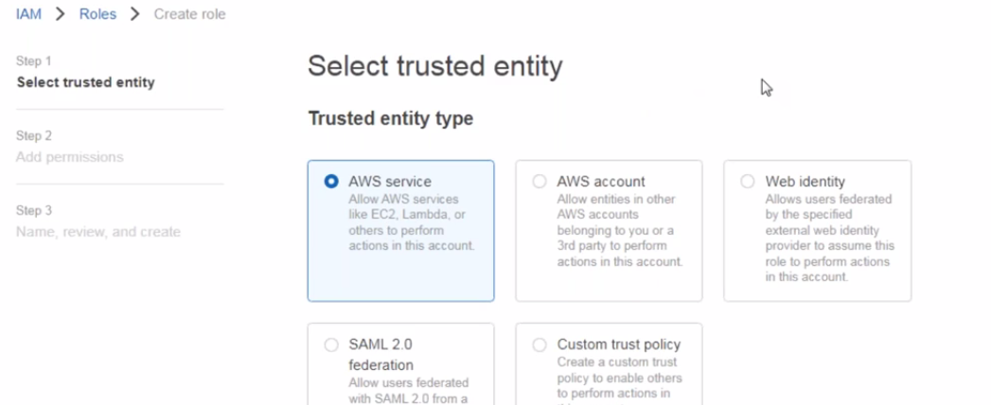

Select the server

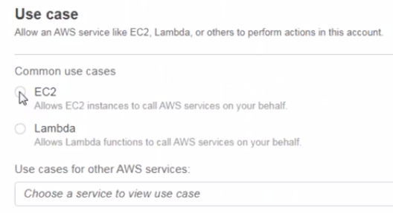

Next and attach the policy what permission has to given to the role

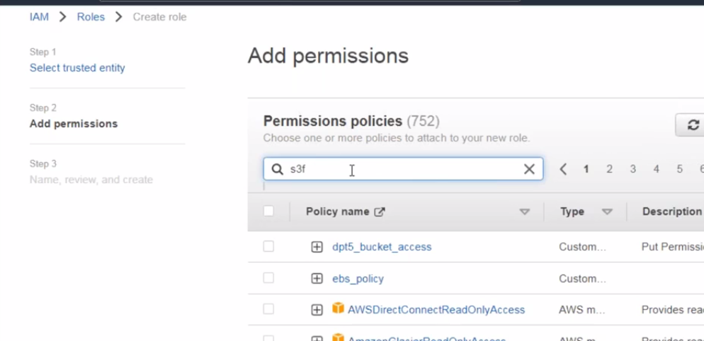

Attach the policy and next

Give the role name

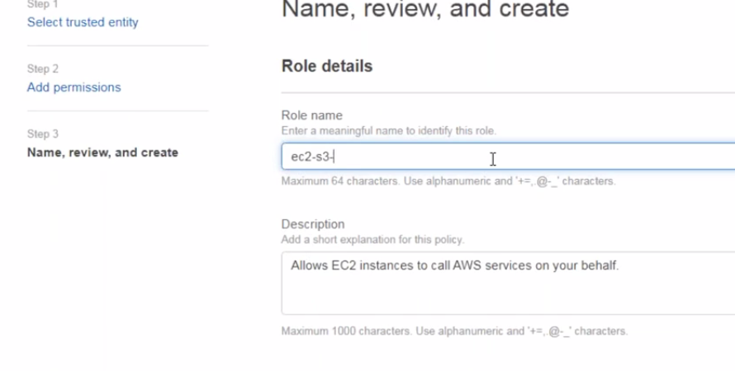

Create arole

Now the role is created and click on the role name

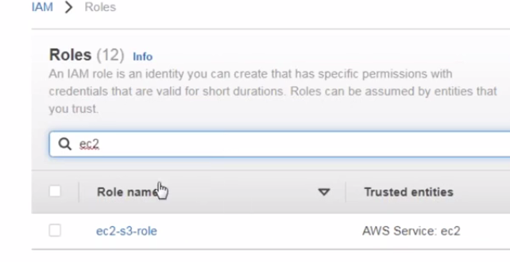

Click on the trust relationships-- This is where we see the principle

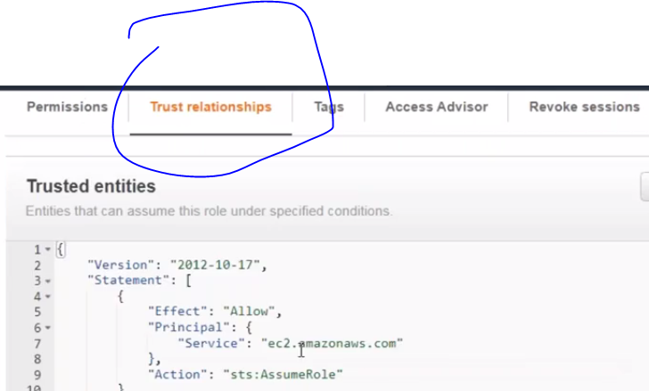

Go back to the server and select the server—actions – security—modity IAM

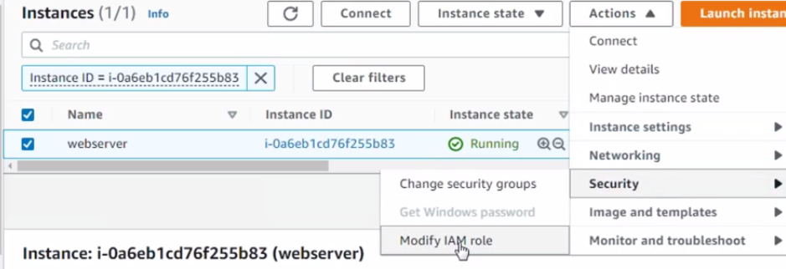 Select the role which created and click save

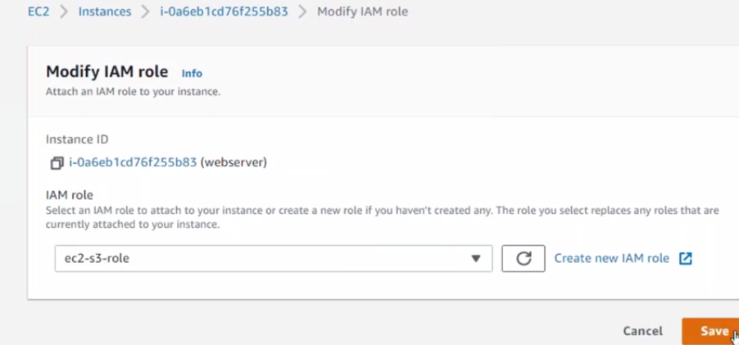

Run the command in linux



Asw s3

Cp – copy

Source Destination

Req:- every week ec2 serves has to rebot automatically

Search eventbridge :- it’s the service which generates events when ever we wants

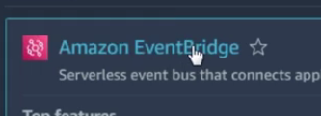

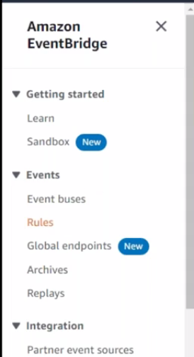 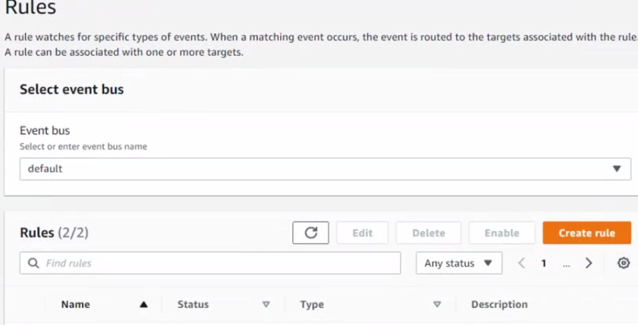

Create a role-- it has to have access to rebot the Ec2 server

We need to have IAM role here

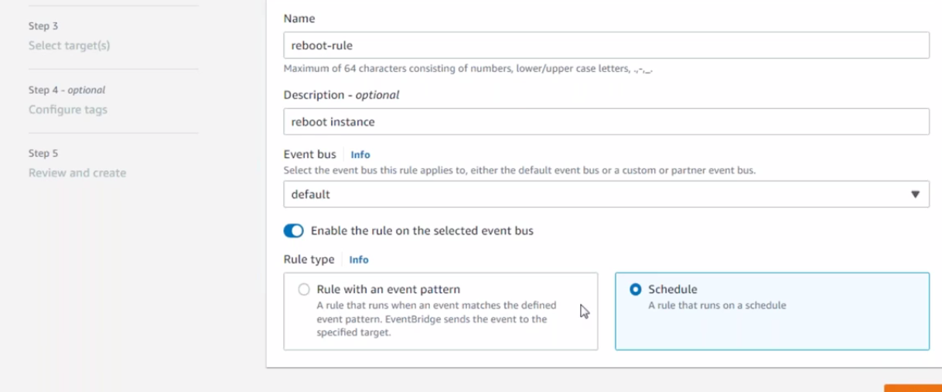

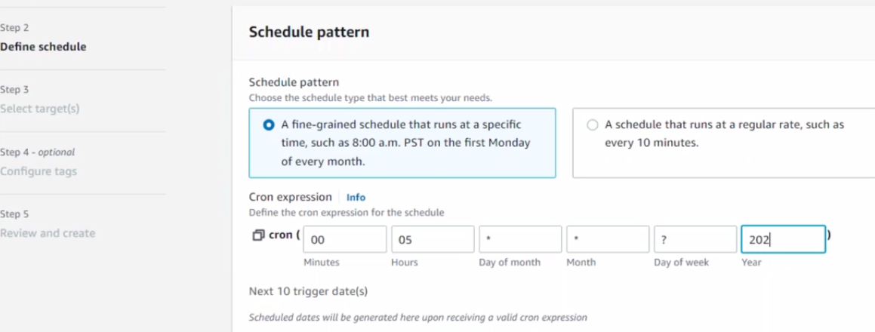

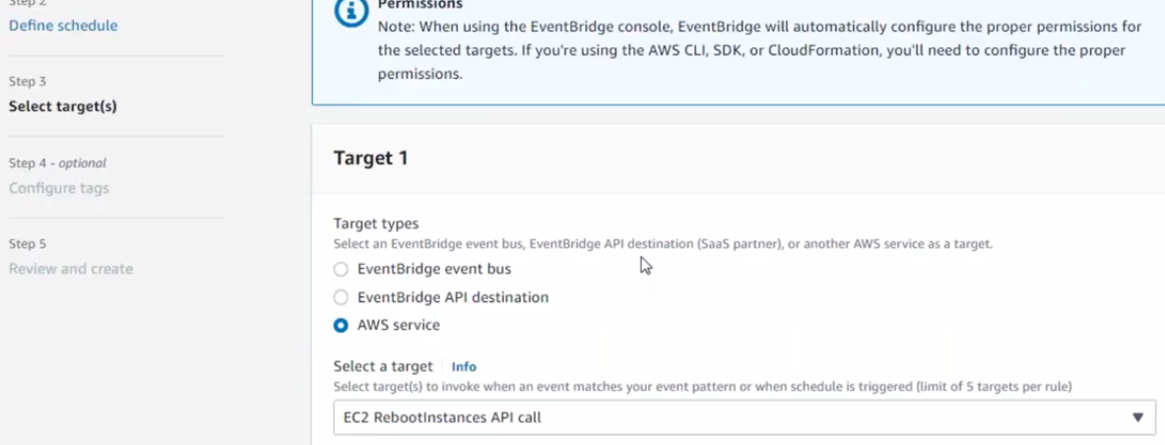

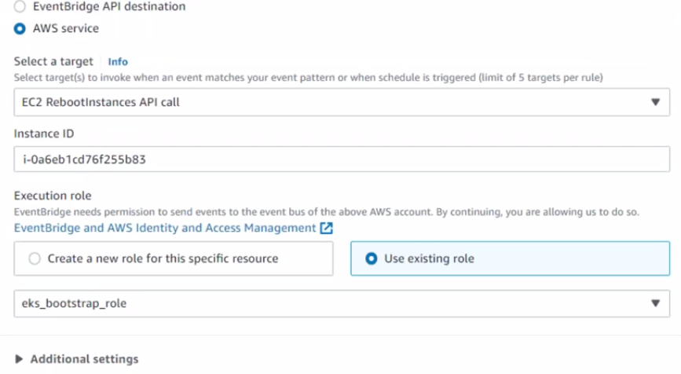

Create a role

If EC2 role has been created we can use in any instances

But in lamda we can use in only lamda

Video 15

Networking basics

A group of systems that’s can be connected to each other is called Network.

A server which is not connected to any server is called standalone/individual

A server which is connected to another server is called network

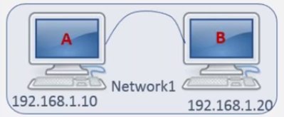

Every system had assigned with a IP address that’s called a identity of system.

Rules of an Ip address:-

* It has to be 4 fields
* Each field the numbers should not be exceed 255
* 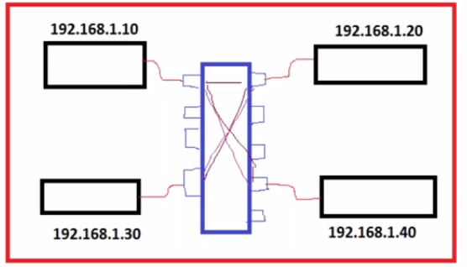

Server in network 1 will not be connected to server in network 2 evenby with network switch

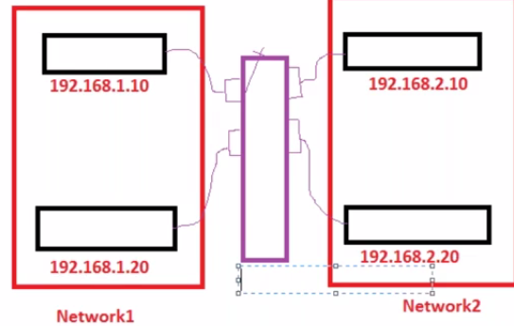

If you have servers with single network you can choose switchs

If different networks you have to use gateways/Routers/hub

Gateway is the capable networking device to route the traffic from one network to another network.

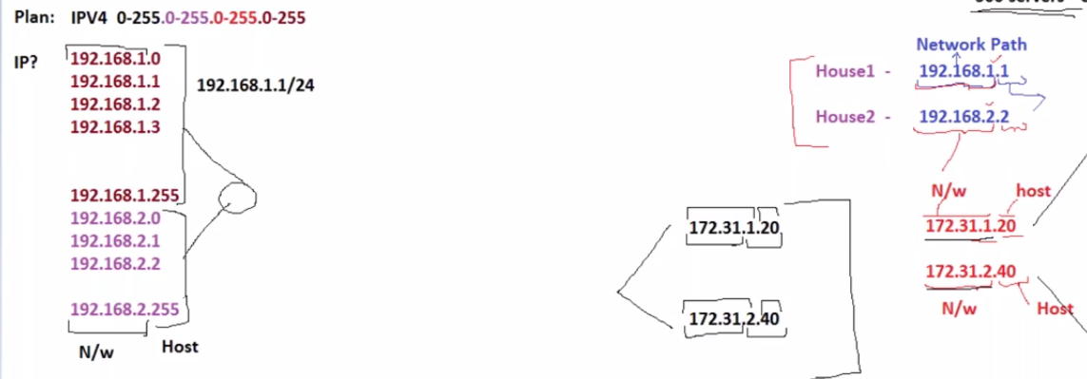

/24 Network ID :- in the given IP 24 bits are using as an network path and remaining using as Host.

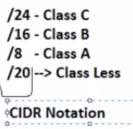 class less inter domain rotation Notation same network ID

It will tell you how much which goes for network path and how much goes for host path.

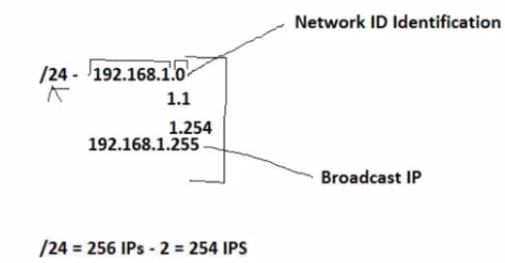

Standard IP formatting rules:-

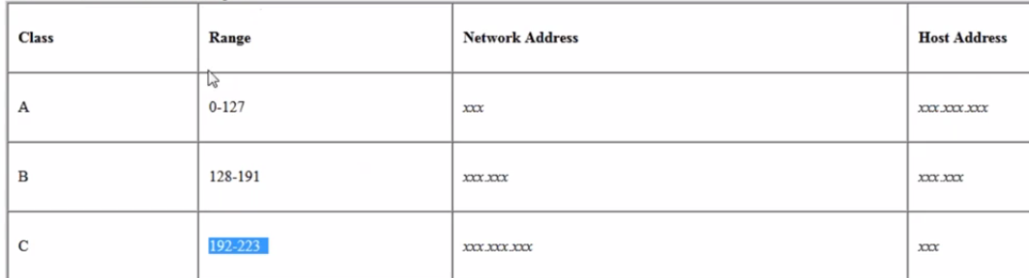

First thing is to check the systems are in same network if its by default its should be connected to each other if not you should be connected through Gateways.

When 2 systems are connected the system which is initiating the connection is called CLIENT

The system which is accepting the connection and giving the response back is called server.

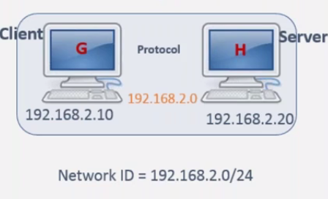

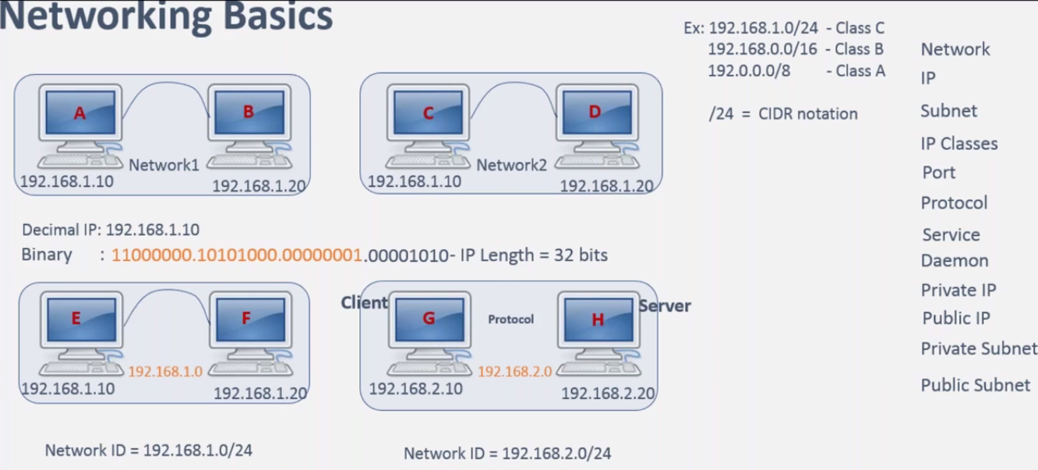

If you are splitting the bits into different part between the network ID and host that’s called sub_Net.

Video 16

Aws vps introduction

First configure and build a bridge network

Pvtip is more secure and reliable

A sytem will have both public and pvt. Pvt IP will use within the data center bcoz it will not access to out sider ip address. public is used outside of the Data center

Pvt ip address can be accessable within the network

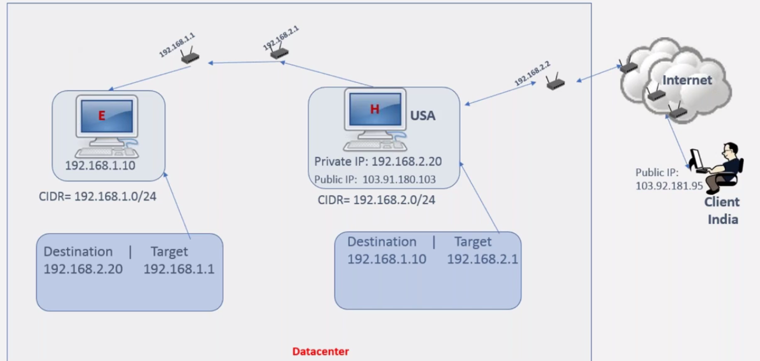

Ends with 1.0 Is a network ID

If 200 ids are falling in one network ID. Better go with the one network 1.0

If you wants to access to public IP which is changes everytime then your netry should be like

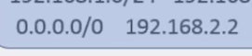 when destination Is all O’s that’s default gateway entry. When its not matching with the pvt IP then it searches for public and connects into that Ip.

Route table is the deciding factor to chek pvt or pblic ip

Building own data centre

* Network :- how many networks should be required
* Network range:- what should be it. Should I go with 182.162.1.0/24 or 2.0./24
* How many servers in each network:-
* How many p/c n/w you are looking for
* Pvt n/w you are looking for , the servers are deployed in pvt n/w are accesable within the data center or outside of the Data center
* Server’s connectivity? :- which server should be connected to which server routing table in this we need to add a route entry stating that for this destination traffic should go to this tgt.
* If possible network switch for physical data centers with cable connectivity
* Local gateway :- it is the to route the traffic from one pvt n/w to another pvt n/w
* Internet gateway :- to route the traffic from public to public over the internet

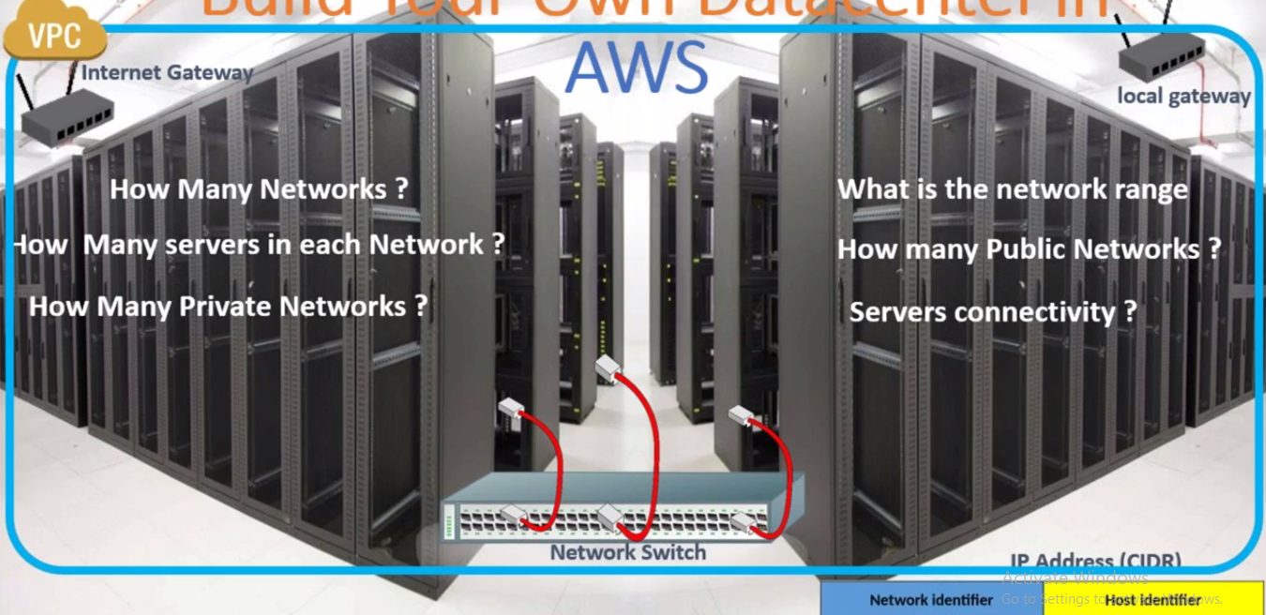

Vpc is the aws service virtual pvt cloud / logical data center in the AWS could its allow us to create own logical data center. configure own network , own public and pvt subnet , maintain own route table.

* First choose the region
* What should be the cidr Ip range of vpc
* In which availability zone u are planning to deploy the server
* In AZ create asubnet :- subnet range should be within the VPC range
* Inside subnet create a security group , inside SG create a ec2 server
* AWS automatically assign a server :- 192.168.1.X
* We only decide the network range
* We need to create a route table , in the route table we need to mention the trees and attach the route table to the subnet
* 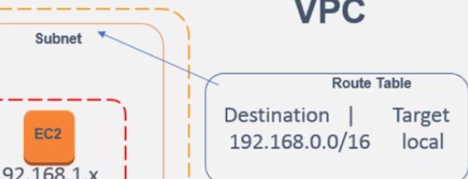
* If dest is withing 0.0/16 then the traffic should be go through local gateway and table is attached to the subnet.
* We are attaching the route table to the subnet . in the subnet all the servers must be following the same route table
* In AWS its not possible to attach the route table to server directly. Always the route table is attach subnet .
* We need to get an internet gateway to attach to the VPC to internet
* Give public ip to the route table and associate it to a public subnet.

The users will connect to the space using the public of the serves.

* It could be a default public IP from aws or elastic ip
* Every subnet should have one route table, but same route table can be used by multiple subnets
* Create another subnet and route table and connect all subnets through the gateways

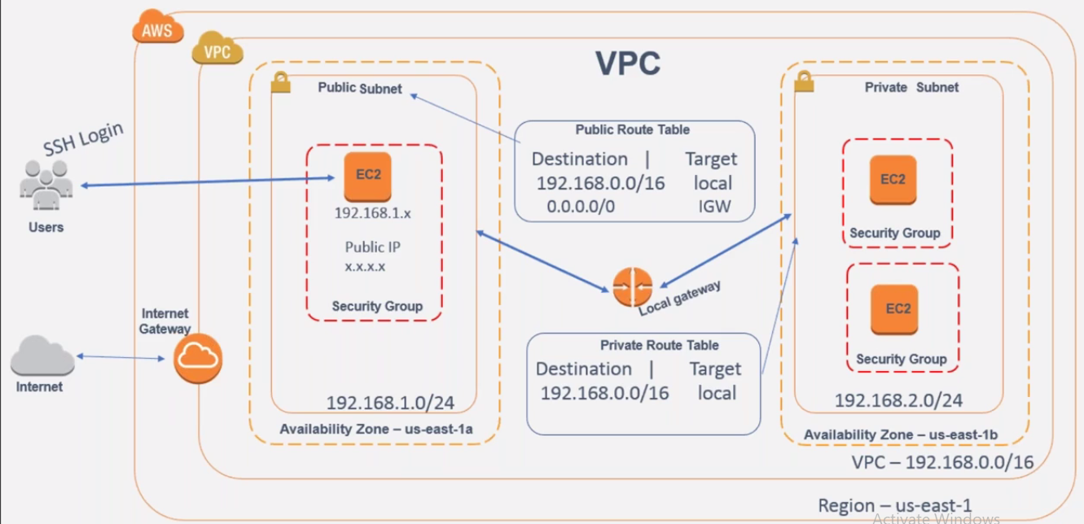

Go choose VPC server

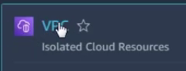

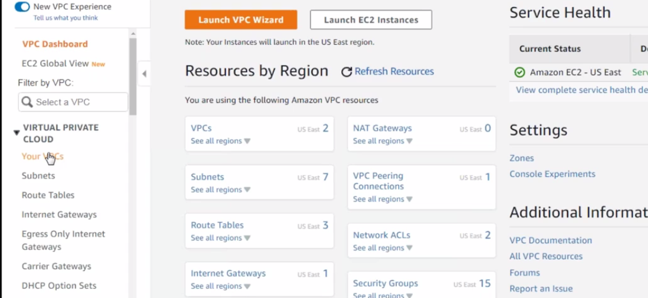

* Go to VPC tab and create own VPC
* 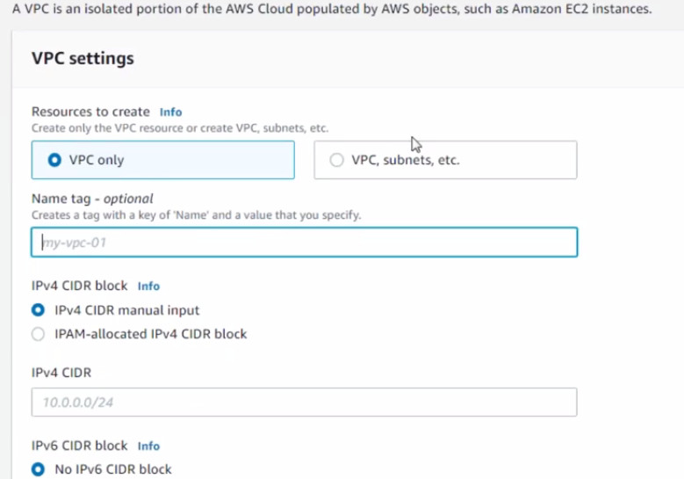

Specify the IPV range , which you wants to choose for your range

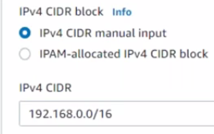create VPC

* Select the internet gateways from drop down – create a internet gate way
* Name - 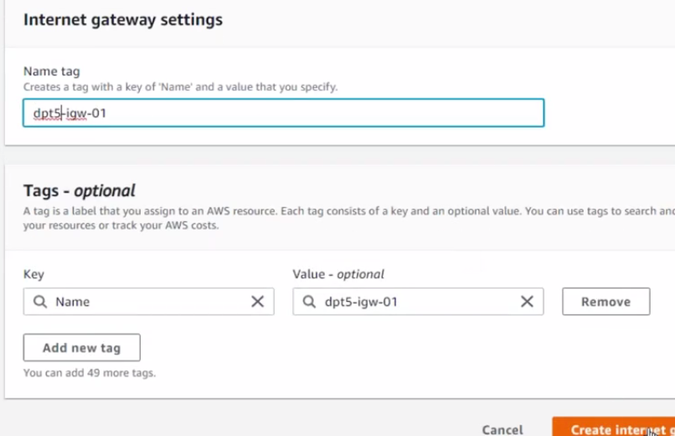

By default its in detatch mode. – actions-- attatch

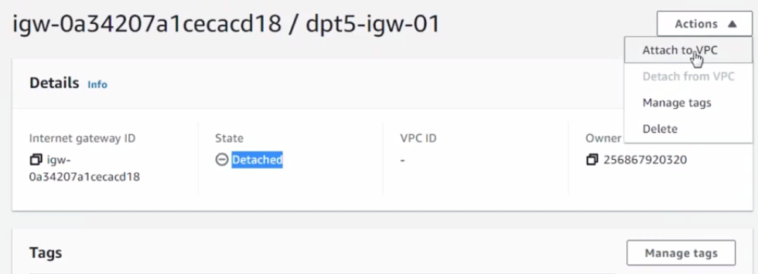

Vps will available in dropdown as its created

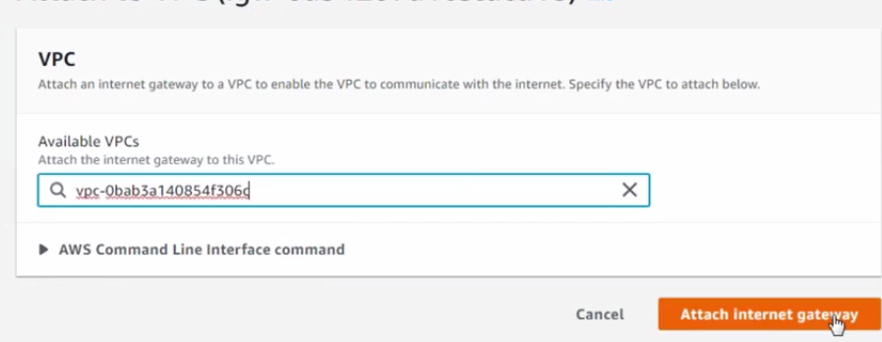

Click subnet option—create subnet—select VPC—

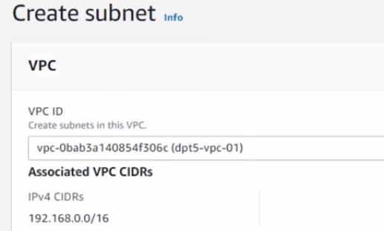

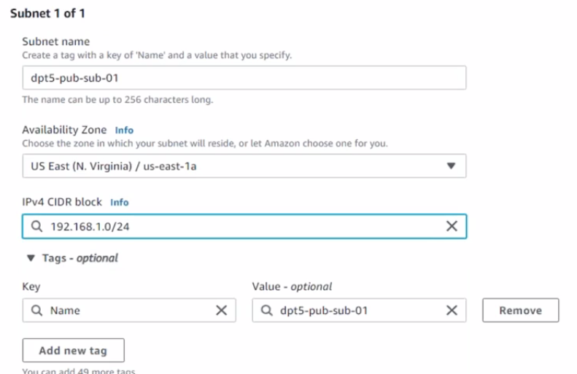

---------------------------------------------------------------

Select route tables—create

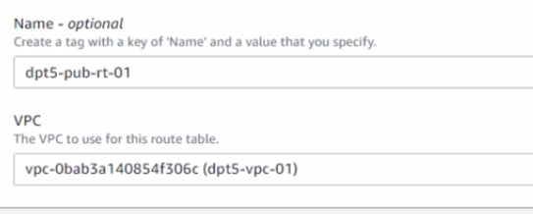

For which VPC you wants to create a route table—crearte a rt

Now attach subnet to route table

In route table go to subnet association tab – edit subnet

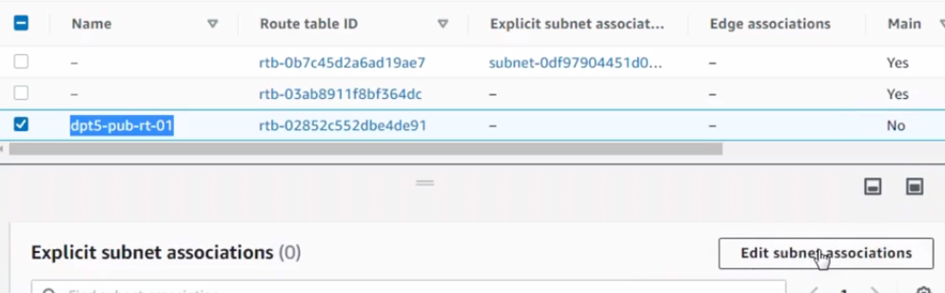

Select the subnet – save

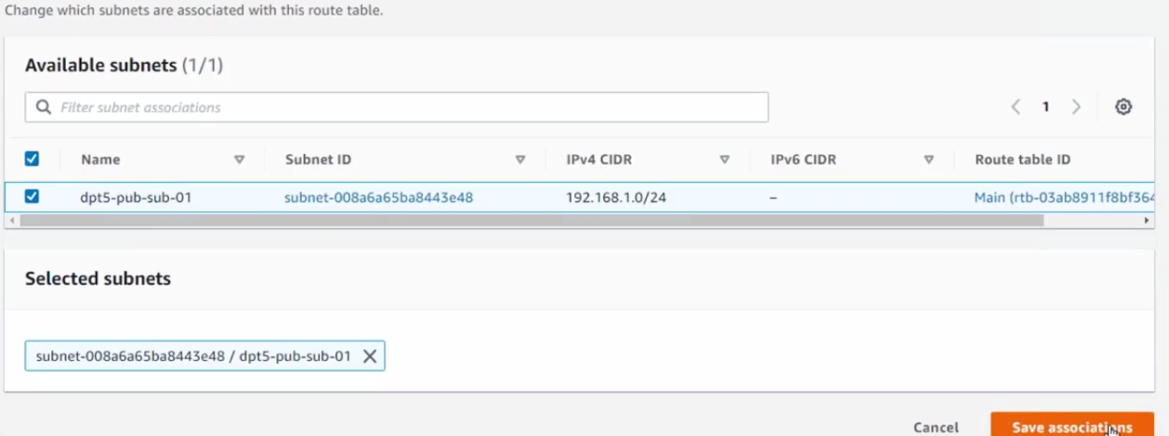

How it routes traffic to destination

Click on routes in the subnet page- by default a local gateway is created and now you need to create a igw .

* Edit routes.—add routes—add destination and tgt

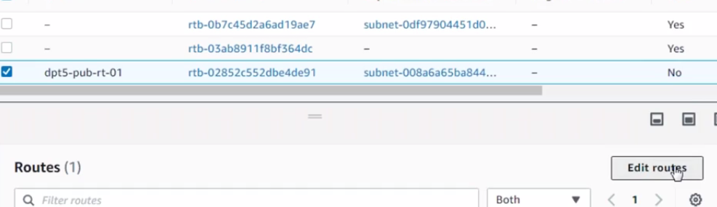

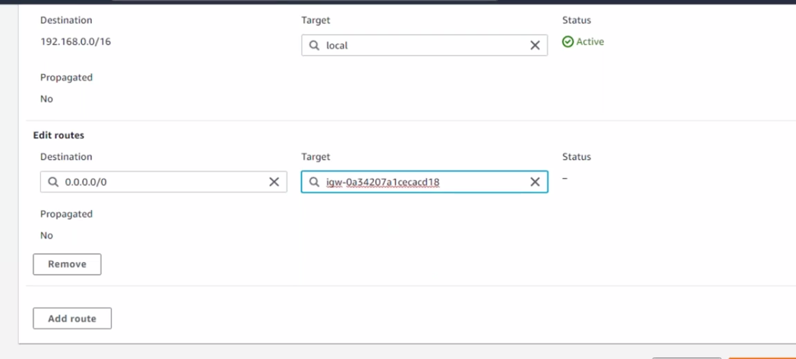

If you wants to get an default public ip . go to actions – edit subnet settigs and enable the Auto assign the Ip settings.—enable auto assign public IP

Automatically a default public ip is assigned and that are deploying in this particular subnet.

6. security group:- which port should allow for network firewall

Go to securitygroup In the menu—create-- name and select the vPS

You should create a security group in your VPC

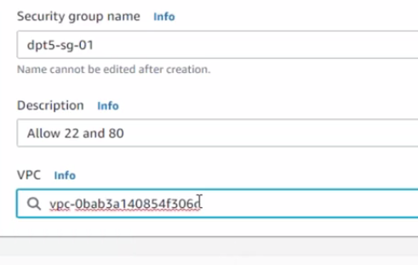

Add inbound rule

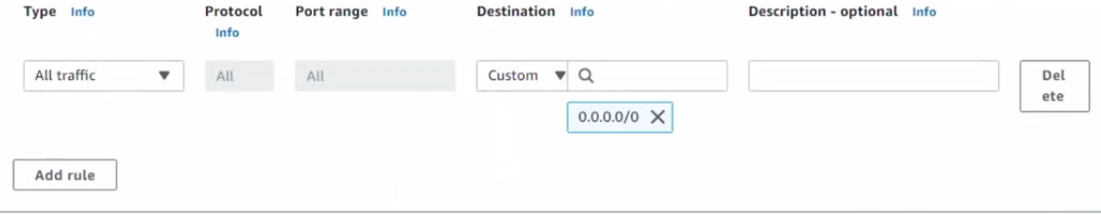

Create it

-🡪 create a EC2

Launch instance—select AMI—key pair—edit networking settings-

Selecy vpc & subnet

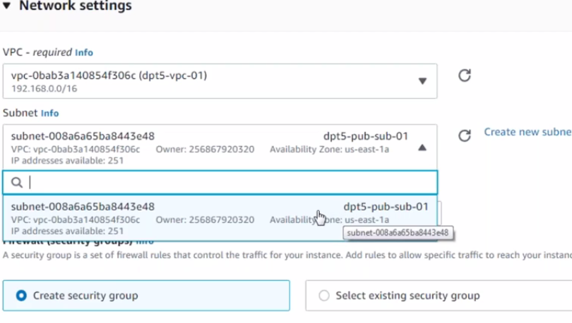

Select the existing security group and choose it form the list

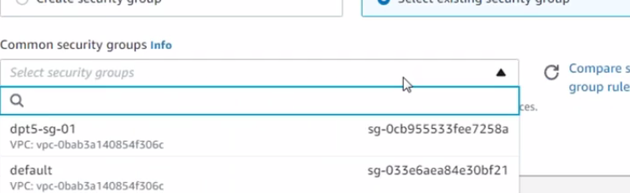

VIDEO 17

Creating the pvt subnet

Vpc search—subnet- create subnet-- select existing vpc—under subnet settings: subnet name- select AZ—ipv4 cidr

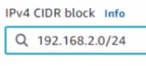

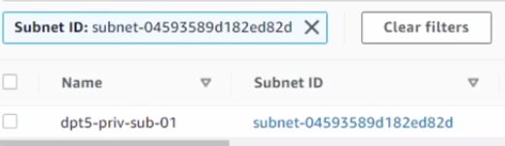

Create a route table –

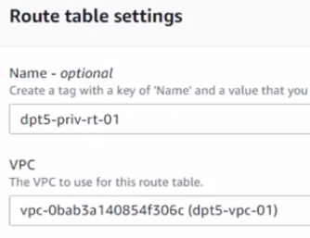 Create route table

Go to subnet association- edit—choose the main subnet with this the existing route table wil be dissociated and main route table will be associated=- save assocatied